**Lab: Prepare the development environment**

Template Version: 2.0

**Introduction**

During this lab, you will learn how to setup an development environment for azure iot hub

**Estimated Time**

20 minutes

**Objectives**

At the end of this lab, you will be able to:

* Install visual studio code
* Install .NET Core SDK
* Install Azure IoT Hub Toolkit extension for visual studio code

**Pre-requisites**

1. Internet Access
2. Active Azure Subscription.

Table of Contents

Lab: Create an Azure IoT Hub 3

Exercise 1: Install Visual studio code 3

Exercise 2: Install .NET Core 3.1 SDK 3

Exercise 3: Install Azure IoT Toolkit VS Code Extension 3

Lab: Create an Azure IoT Hub

During this lab, you will learn how to setup the required tools, create an IoT Hub and use the MXChip simulator.

Exercise 1: Install Visual studio code

Go to this link: <https://code.visualstudio.com/download> to download and follow the steps to install Visual studio code on your system.

Exercise 2: Install .NET Core 3.1 SDK

Go to this link: <https://dotnet.microsoft.com/download> to download and follow the steps to install .NET Core 3.1 SDK on you system

Exercise 3: Install Azure IoT Toolkit VS Code Extension

This exercise shows how to add the Azure IoT Toolkit Extension to Visual Studio Code

Tasks

1. On the Desktop, double click on Visual Studio Code Icon

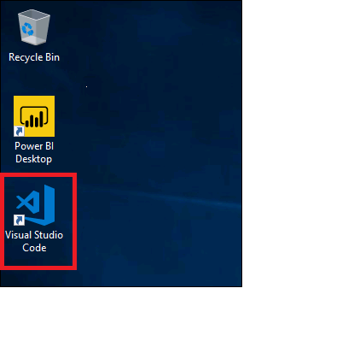

Press F1 on the Welcome Page

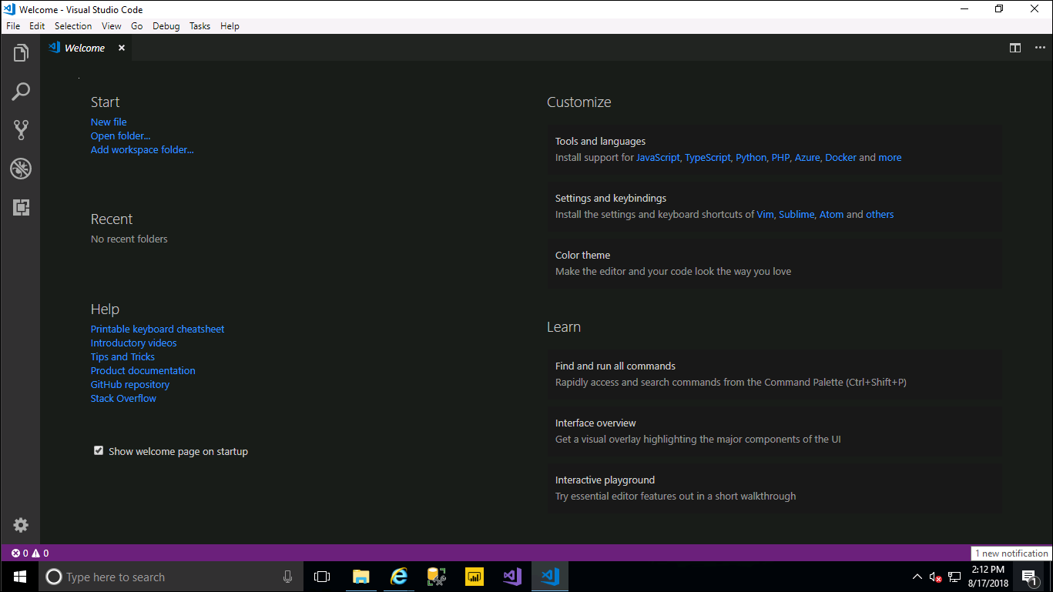

Open a browser and navigate to the following url:

<https://marketplace.visualstudio.com/items?itemName=vsciot-vscode.azure-iot-toolkit>

Click on Install

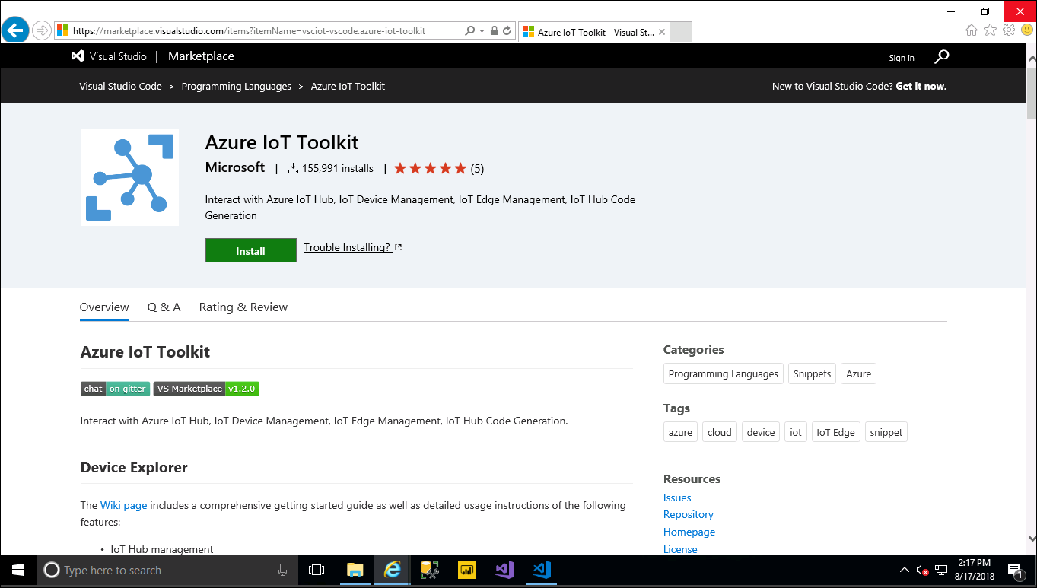

If you receive a popup about Visual Studio Code requirements, click on **Continue**

If you receive a popup about allowing this website to open a program on your computer, click **Allow**

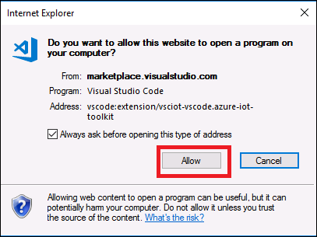

Click on **Install** in Visual Studio Code to install the Azure IOT Toolkit.

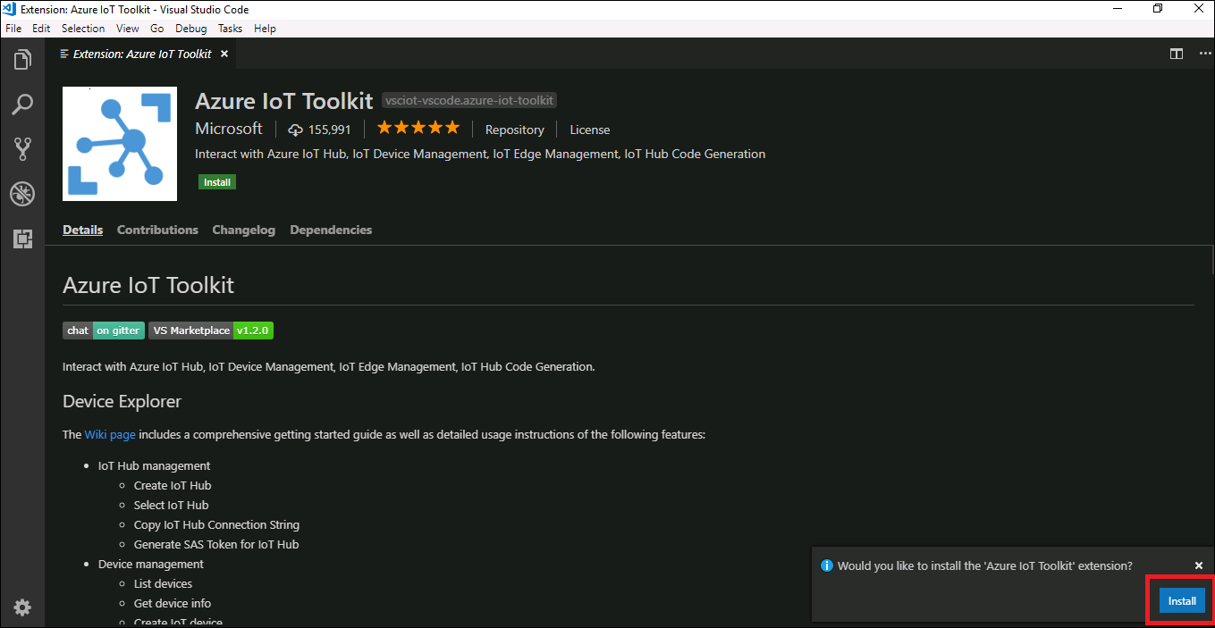

Click on **Reload** after the installion completed

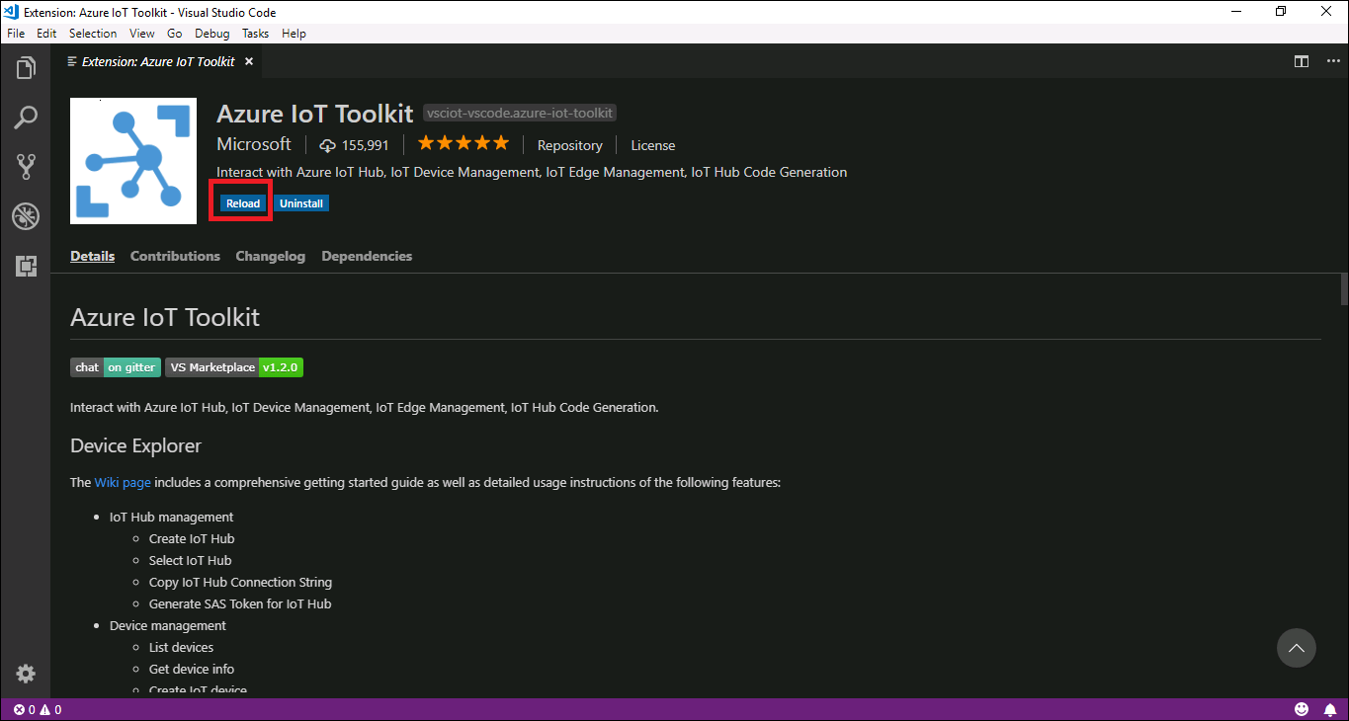

Logon to Azure, click **Sign In**

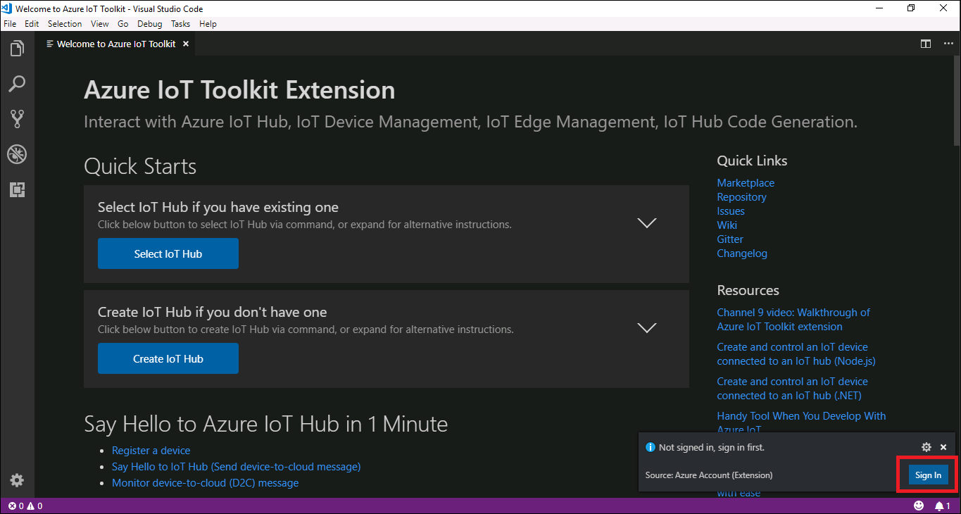

Click on **Copy** and **Open**

This will open a browser and copy the code require for the device login page.

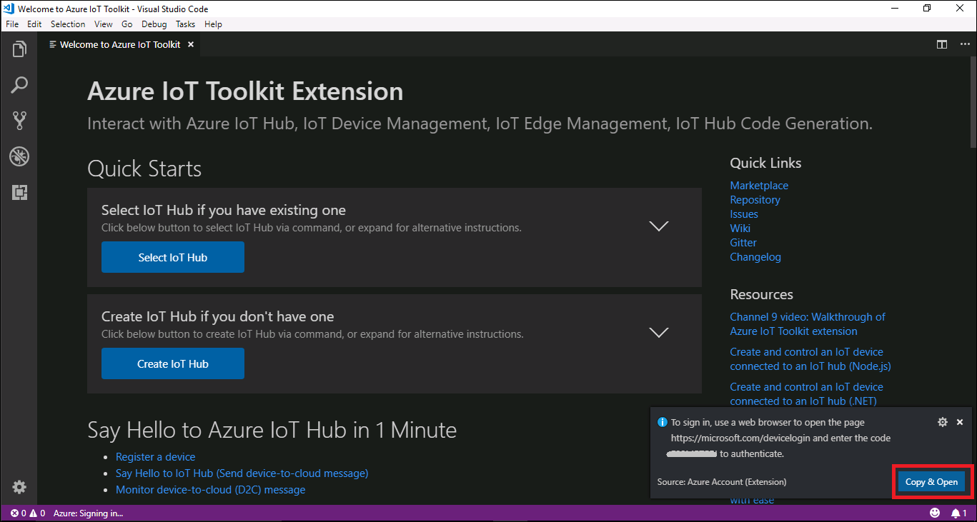

Paste the code from the previous page in the device login page by clicking **CTRL V** and click **Continue**

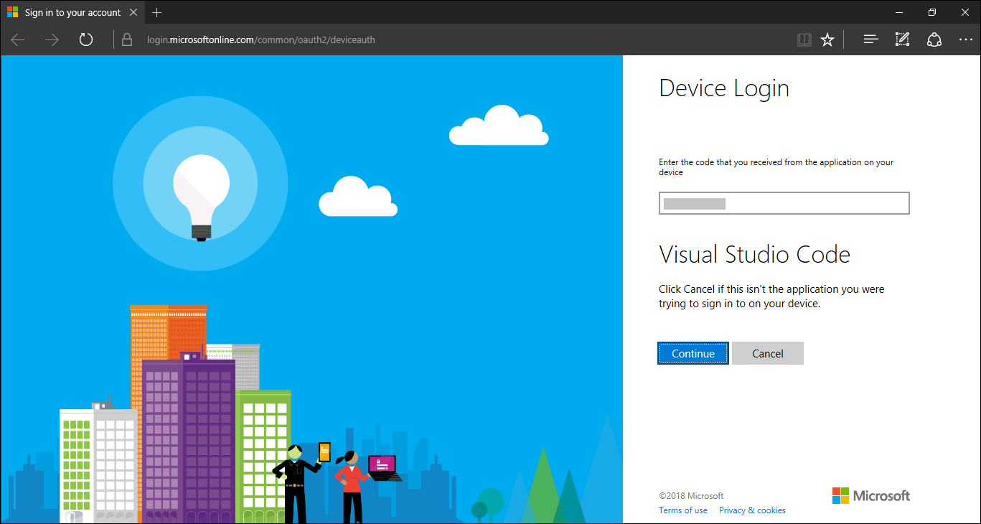

Type in a valid user name.

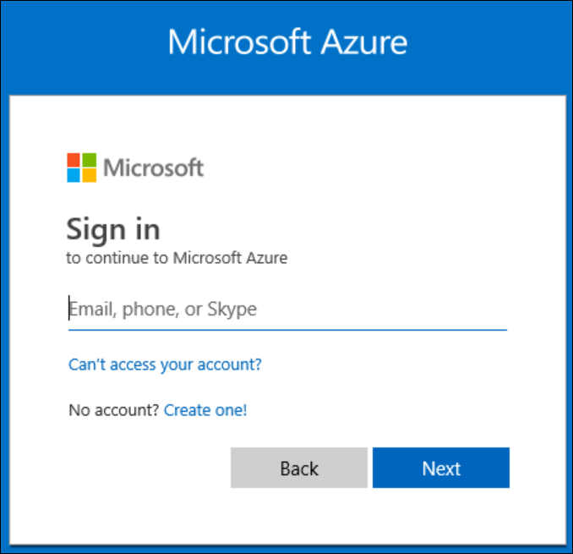

Select **Sign in** **with a username and password instead**

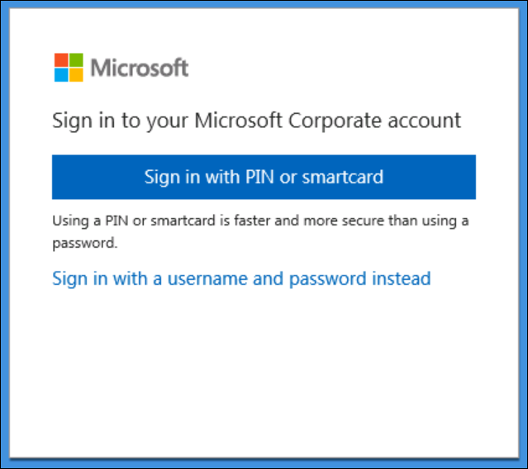

Enter your password and click on Sign In

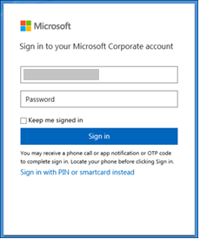

Click on **Sign in with your phone or token device**

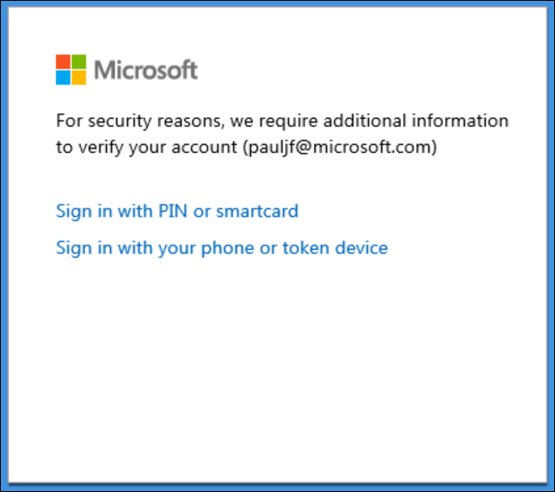

You will receive a phone call to verify your pin

You are now signed into your azure account and ready to continue… close this page

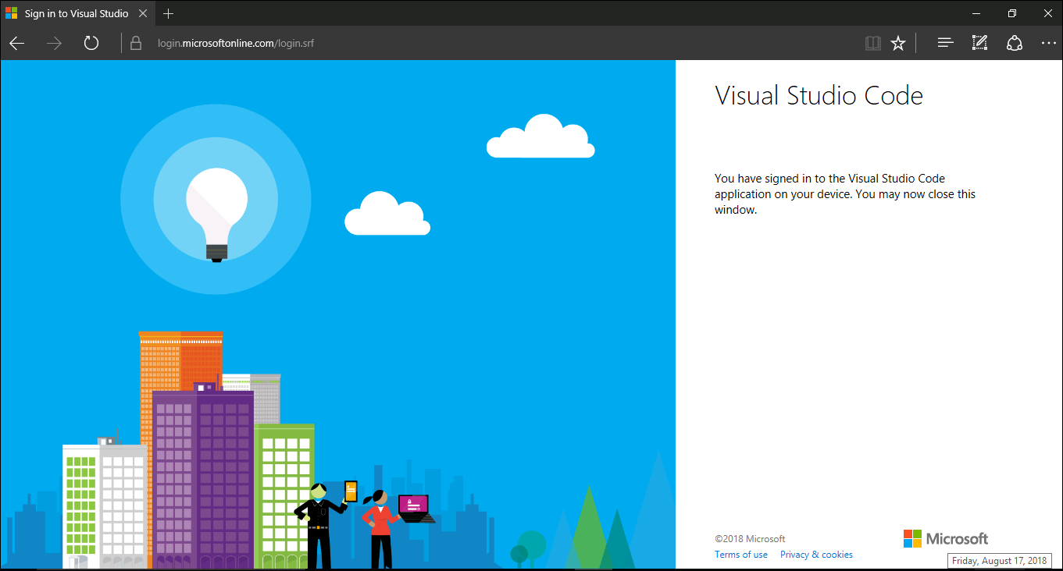

Select your Active Azure Subscription

